Grand Oaks Mail Center
Boxes, Packing & Shipping Supplies
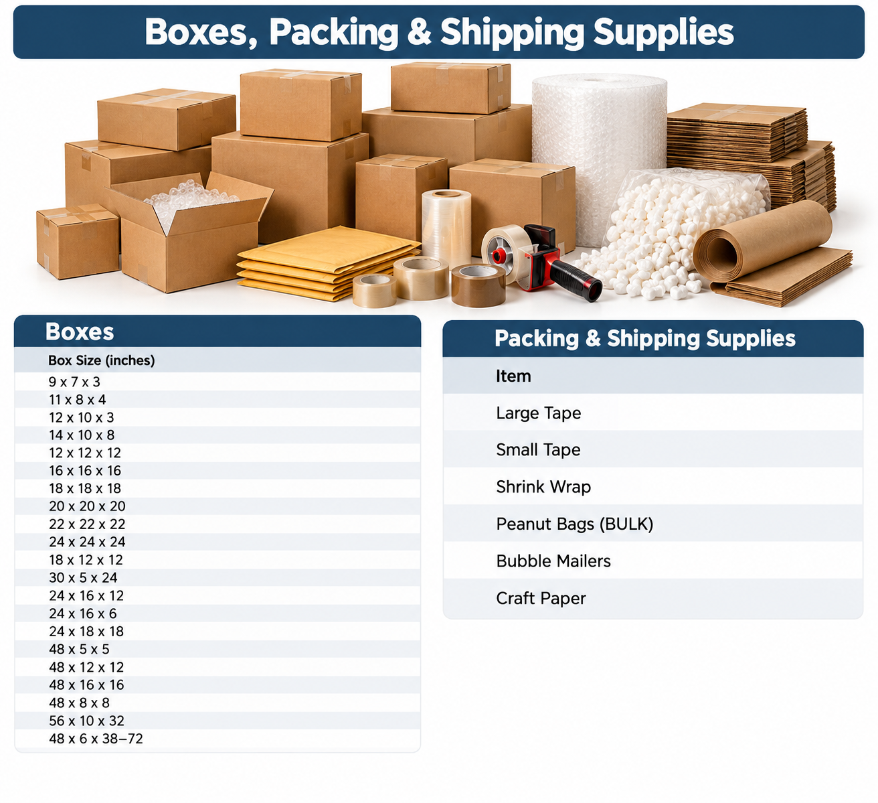
Boxes
- 9 x 7 x 3
- 11 x 8 x 4
- 12 x 10 x 3
- 14 x 10 x 8
- 12 x 12 x 12
- 16 x 16 x 16
- 18 x 18 x 18
- 20 x 20 x 20
- 22 x 22 x 22
- 24 x 24 x 24
- 18 x 12 x 12
- 30 x 5 x 24
- 24 x 16 x 12
- 24 x 16 x 6
- 24 x 18 x 18
- 48 x 5 x 5
- 48 x 12 x 12
- 48 x 16 x 16
- 48 x 8 x 8
- 56 x 10 x 32
- 48 x 6 x 38-72
Packing & Shipping Supplies
- Large Tape
- Small Tape
- Shrink Wrap
- Peanut Bags (BULK)
- Bubble Mailers
- Craft Paper

